PROJECT DESIGN PHASE - II TECHNOLOGY STACK( ARCHITECTURE & STACK)

|  |  |
| --- | --- |
| Date | 15 October 2022 |
| Team ID | PNT2022TMID12349 |
| Project Name | Personal Assistance for Seniors Who Are Self-Reliant |
| Maximum Marks | 4 Marks |

Technical Architecture :

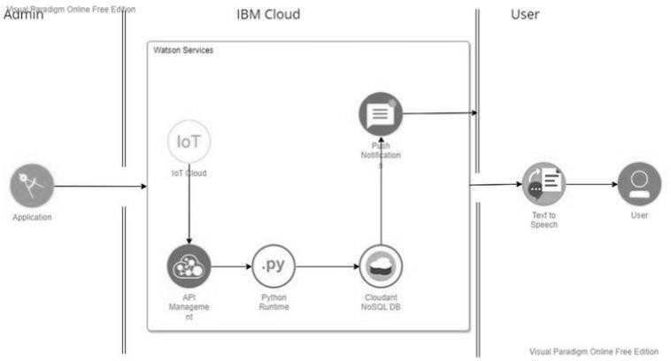

Table-1: Components & Technologies:

|  |  |  |  |
| --- | --- | --- | --- |
| **S.No Component Description Technology** | | | |
| **1.** | User Interface Mobile App | | **HTML, CSS,** |
|  |  | | **JavaScript** |
| **2.** | Application Logic-1 | Mobile App to enter the Medicine | **Python** |
|  |  | Details weekly |  |
| **3.** | Application Logic-2 Gets the medication data from  database | | **IBM Watson IoT API Call data** |
| **4.** | Application Logic-3 | Converts the text to speech to pronunciation for theuser | **IBM Watson Assistant** |
| **5.** | Database Medication time and tablets name on daily and | | **MySQL** |
| **6.** | Cloud Database | Call the data IBM Cloudant is used and user logincredentials | **IBM DB2, IBM**  **Cloudant** |
| **7.** | File Storage App code and IoT credentials are stored and APIkeys | | **IBM Block Storage** |
| **8.** | External API-1 | To get the medicine box status Open or not | **IBM box status API** |
| **9.** | External API-2 To get the login credentials in IBM DB2 | | **Username and Password API** |
| **10.** | Machine Learning Model | To convert the text into speech for voice commandthe tablet details | **Text to speech** |
| **11. Infrastructure To host the server and Cloud Foundry, (Server / Cloud) application Node Red** | | | |

Table-2: Application Characteristics:

|  |  |  |  |
| --- | --- | --- | --- |
| **S.N Characteristics o** | | **Description** | **Technology** |
| **1.** | Open-Source Frameworks | To develop the application interface, we use  **MITApp Inventor** | **MIT APP INVENTOR** |
| **2.** | Security Implementations | To secure the users login credentials and personalinformation | **SHA-256, OWASP** |
| **3.** | Scalable Architecture | To scale the application database | **IBM Auto scaling** |
| **4.** | Availability | To make use the application and data areavailable 24/7 | **IBM Cloud load balancer** |
| **5. Performance** | | **To increase the performance the application**  **inhosted in the high- performance instance** | **IBM instance** |